    Stay Informed About Updates, Events, and More! | 02/18  FEBRUARY  NEWSLETTER

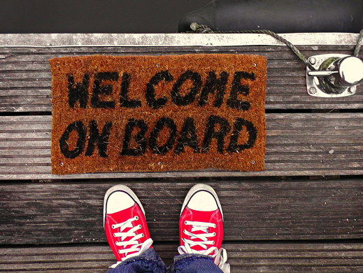 |  | 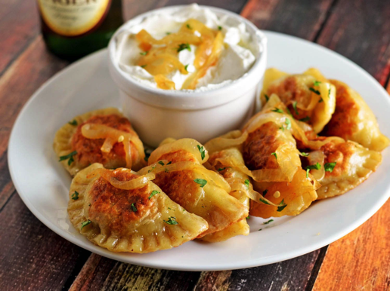
 ISPPU Open House  FRIDAY, FEBRUARY 16TH | 11AM – 2PM | CARL A. FIELDS CENTER  We invite all spouses & partners of international scholars and graduate students as well as their children to attend our newcomers Welcome Party!  **Lunch will be provided to registered attendees – please RSVP by Feb.12** | WINTER DRINKS  FRIDAY, FEBRUARY 16TH | 6.30PM – 10.30PM | TBC  Join us for winter drinks! Let's get together and enjoy a drink or two among friends! :) | POLISH COOKING CLASS  SUNDAY, FEBRUARY 25TH | 10AM – 2PM | TBC  The second cooking class of the year is coming! This time, the theme will be Polish Cuisine! Details about menu and registration will be updated soon. Check your email!
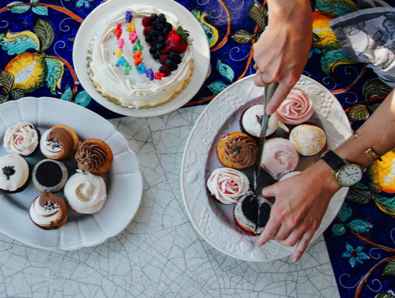 | ISPPU BIRTHDAY PARTY & POTLUCK  SATURDAY, MARCH 10TH | 3PM - 5PM | LAKESIDE APARTMENTS, COMMONS ROOM  Come and celebrate the ISPPU Birthday with us! ISPPU will provide a cake and please bring a dish to share for our potluck. More information to come soon.

RECURRING WEEKLY EVENTS

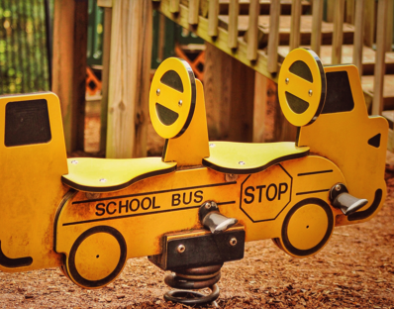 | CHILDREN'S MEET-UPS  EVERY MONDAYS | 10AM - 12PM | LAWRENCE APARTMENTS  Please join us at Lawrence Apartments, as the weather turns rainy and cold to play with toys, socialize and interact with other children! Open to all ISPPU families and caregivers. Anyone else that may want to learn more about family activities in Princeton or what it's like to raise a family here is also welcome. Hope to see many of you very soon!
 | LET’S WORK OUT TOGETHER  EVERY WEDNESDAY | 10AM – 11AM | 14 LAWRENCE COMMON ROOM  Working out with friends is always more motivating and fun. This activity is totally casual. Everyone is welcome. We will work out using basic videos, and you can also share what you would like to do or do whatever you need to!  The venue is the 14 Lawrence common room, Google Map pin: here. If you aren't a Lawrence resident, you can park in the guest parking area on Lawrence Drive.  Guest parking google map pin: here.  **This is a kid-friendly event. You can bring kids to play in the room. The room has toys that kids can share**  Please call or send a message to Jean if you can't get into the building: 317-999-8061.  We hope to see you there! ❤❤
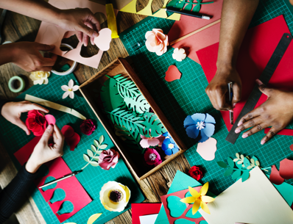 | CRAFTY CLUB  EVERY THURSDAYS | 7.30PM - 8.30PM | JADWIN PHYSICS DEPARTMENT, LEVEL 1 WHERE THE COUCHES ARE  Do you like to knit or crochet? To do needlepoint or colouring? Bring whatever project you're working on, good conversation and let's craft away!  And don't worry, you don't have to be an expert crafter or even one at all! Join us anyway and spend some time with friends!

