  Updates, events, and more. Stay well informed ! | NEWSLETTER
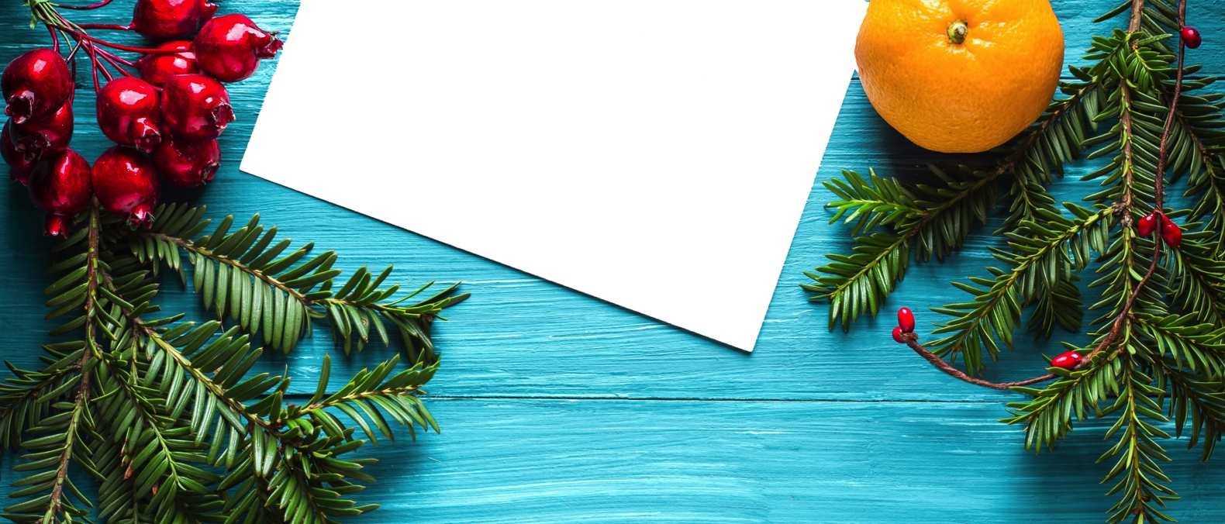

UPCOMING EVENTS   FALL DRINKS PART.2  SATURDAY, DECEMBER 2ND | 6.30PM – 10.30PM | YANKEE DOODLE TAP ROOM  Join us for the second edition of Fall Drinks! Let's get together and enjoy a drink or two among friends! :)  CHILDREN'S MEET-UPS  EVERY MONDAYS | 10AM - 12PM | LAWRENCE APARTMENTS  Please join us at Lawrence Apartments, as the weather turns rainy and cold to play with toys, socialize and interact with other children! Open to all ISPPU families and caregivers. Anyone else that may want to learn more about family activities in Princeton or what it's like to raise a family here is also welcome. Hope to see many of you very soon!  CRAFTY CLUB  EVERY THURSDAYS | 7.30PM - 8.30PM | JADWIN PHYSICS DEPARTMENT, LEVEL 1 WHERE THE COUCHES ARE  Do you like to knit, crochet? To do needlepoint or colouring? Bring whatever project you're working on, good conversation and let's craft away!  And don't worry, you don't have to be an expert crafter or even one at all! Join us anyway and spend some time with friends!  HOLIDAY PARTY & POTLUCK  SUNDAY, DECEMBER 9TH | 5PM - 9PM | LAKESIDE APARTMENTS, COMMONS ROOM  Come and celebrate the Holiday season with ISSPU!  Please bring a dish to share for our potluck. Need ideas? Or maybe there’s some traditional festive food from your country that you like to bring? Anyway, we’re looking forward to having a delicious, international buffet as always!  ISPPU will prepare some water and pop (you may bring a grown-up drink), music, and the following activities that we hope everyone likes to get involved in:  - Join us for Gingerbread house making! Who will create the most impressive candy mansion?!*  - White elephant gift exchange - It’s a gift exchange game where everyone who participates ends up taking a gift home! Wanna join? Bring one wrapped gift (10$ max) to the party!*  - Cookie exchange: If you want to take some nice cookies home for you and your family and maybe get some new baking ideas, please prepare a badge of at least 20 cookies or small deserts and bring them to the party. Please also share your recipe! We will provide little gift bags, so everyone who brought cookies gets to take home a bag of different cookies. Yummie!*  Please RSVP until Dec, 1st, and let us know if you’ll bring your partner, international guests or kids.  We will need three people to volunteer to clean up once the party is over. Usually there’s not a lot to do, but it would be nice if some of you could commit to staying until the party is over and help with this - let us know by sending us an email. Thank you! | IN THIS ISSUE  Sat, Dec 2, 6.30pm  Fall Drinks Part.2  Mondays, 10am  Children's Meet-ups  Thursdays, 7.30pm  Crafty Club  Sun, Dec 9, 5pm  Holiday Party & Potluck
