  Updates, events, and more. Stay well informed ! | NEWSLETTER
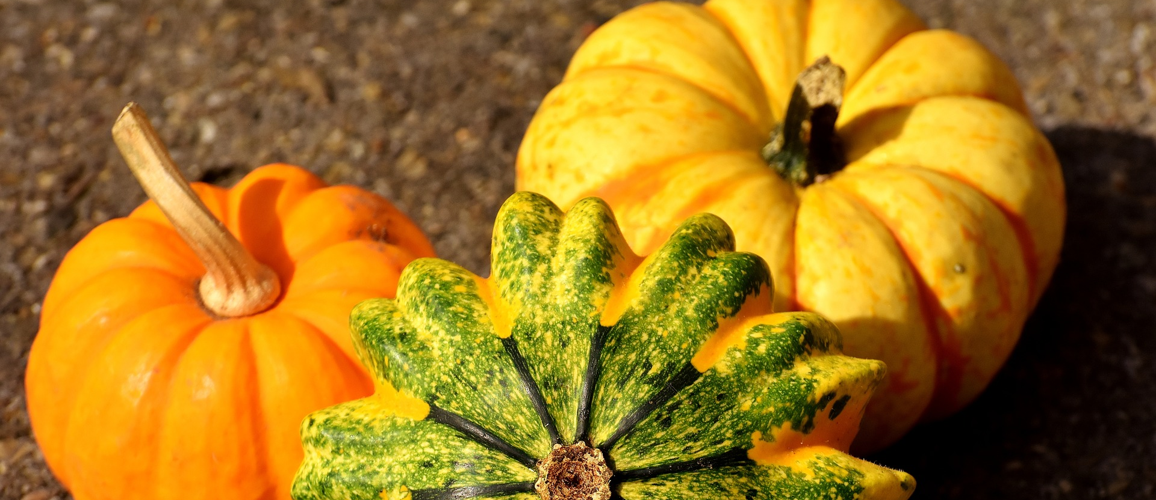

UPCOMING EVENTS  HALLOWEEN PARTY  SUNDAY, OCTOBER 29 | 5PM - 9PM | LAKESIDE COMMONS  Come one, come all to our spooky Halloween Party! There will be games, music and prizes. Be sure to wear your best costume as there will be prizes given out to both children and adults! Please bring a dish to share as we will have a potluck style supper meal.  CHILDREN'S MEET-UPS  EVERY MONDAYS | 10AM - 12PM  Open to anyone and everyone who would like to spend some time playing with children, visiting with parents or just enjoying summer. This is a great way to meet other international families at Princeton University. Feel free to come and go as you please.  CRAFTY CLUB  EVERY THURSDAYS | 7.30PM - 8.30PM | JADWIN PHYSICS DEPARTMENT, LEVEL 1 WHERE THE COUCHES ARE  Do you like to knit, crochet? To do needlepoint or colouring? Bring whatever project you're working on, good conversation and let's craft away!  And don't worry, you don't have to be an expert crafter or even one at all! Join us anyway and spend some time with friends!  FRENCH COOKING CLASS  SUNDAY, NOVEMBER 12 | 10AM - 2PM | LAWRENCE APARTMENTS, COMMUNITY KITCHEN  It is finally time for our first cooking class of the year! This time, the theme will be French Cuisine!! (Don’t expect something too fancy though ) Details about menu and registration will be updated soon. Watch your email !  THANKSGIVING PARTY  SUNDAY, NOVEMBER 19 | 5PM - 9PM | CARL FIELDS CENTER, 1985 MEETING ROOM  Come and join us for our yearly Thanksgiving feast! As there is no thanksgiving feast without turkey, we will provide the turkey. Please bring your favorite dish to share as we will have a potluck style supper meal.  FALL DRINKS PART.2  DATE, TIME & LOCATION TO BE CONFIRMED  Join us for the second edition of Fall Drinks! Let's get together and enjoy a drink or two among friends! :) | IN THIS ISSUE  Sun, Oct 29  Halloween Party  Mondays 10am  Children's Meet-ups  Thursdays 7.30pm  Crafty Club  Sun, Nov 12  French Cooking Class  Sun, Nov 19  Thanksgiving Party  TBC  Fall Drinks Part.2
