isppu news
International Spouses and Partners of Princeton University

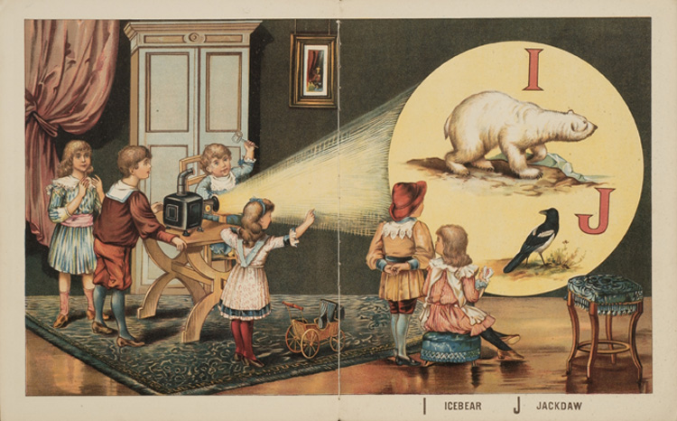


May 2017

ISPPU Events
In This Issue
- Children’s Meet-ups
Mon, 10 AM (Weekly)
- ISPPU Café
Weds, 3 – 4 PM (Weekly)
- Book Club
Tue, May 23
- Career Kickoff Workshop:
Design Your Life 3.0
Wed, May 3
- Lunch & Chat:
Fri, May 19
- Year End BBQ
Sat, Apr 22
- Guided Tour of PU Art Museum
Sat, Apr 29
- Communiversity
Sun, Apr 30

Children’s Meetup

Mondays | 10:00 AM – 12:00 PM | Cotsen Children’s Library (Inside Firestone Library)
It takes a village to raise a child, so why do it alone? Come to our weekly Children’s Meetup where little ones can play with each other while parents can share their childcare stories and tips. Contact Mel at konkel.mel@gmail.com for more information.

ISPPU Café

Wednesdays | 3:00 – 4:00 PM | Atrium Café, 20 Washington Rd
Join us for our weekly meet-up on Wednesdays in the Atrium Café. It’s a great place to meet other ISPPU member and talk about life in Princeton over a cup of coffee of tea. Children are welcome. In case the café is booked for other events, visit Campus Club on 5 Prospect Avenue.

Book Club

Tue, May 23 | 4:30 PM | Halo Pub, 9 Hulfish St
We’ll discuss The Refugees by Pulitzer Prize winner Viet Thanh Nguyen, a collection of perfectly formed stories written over a period of twenty years, exploring questions of immigration, identity, love, and family. Firestone and the Princeton Public library have several copies. Contact isppu@princeton.edu for more information.

Contact us

Email: isppu@princeton.edu | Join Us: tinyurl.com/isppu-request | Facebook: www.facebook.com/groups/isppu

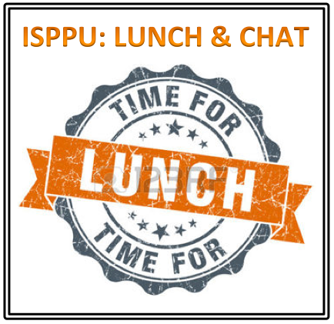

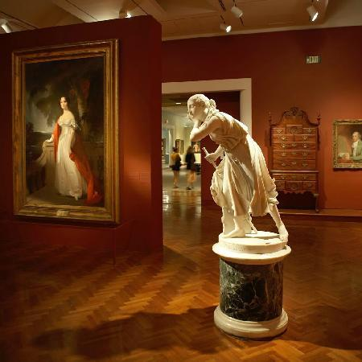

Career Kickoff Workshop: Design Your Life 3.0

Wed, May 3 | 7:00 – 8:30 PM | Louis A. Simpson (LAS) International Bldg. MPR B60B, 20 Washington Road

This is a continuation of our previous Career Kickoff Workshop. The workshop is based on a similar workshop offered by Princeton University Career Services and Keller Center for Innovation in Engineering Education. Suggested reading: Designing Your Life: How to Build A Well-lived, Joyful Life. Contact us at isppu@princeton.edu for more information.

Lunch & Chat: Structured Life

Fri, May 19 | 12:30 – 1:30 PM | Suite 301, 20 Washington Road
Join us for lunch at the monthly Lunch & Chat Discussion Group. The topic this month is Structured Life – navigate ways to finding a structure in Princeton. The discussion will be facilitated by Shefalika Gandhi, LCSW from UHS. Fruits and tea will be provided. You are encouraged to bring your own lunch. Contact us at isppu@princeton.edu to RSVP by Wed, May 17.

Year End BBQ

Sun, May 14 | 5:00 PM – 8:00 PM | Lakeside Commons and Grill Area
"An unbirthday is an event that is typically celebrated on any or all of the 364 (365 on leap years) days in which it is not the person's birthday." This will be a party to celebrate the birthdays (or unbirthdays) of all ISPPU children in one party. There will be party hats, crafts and games. ISPPU will provide hotdogs and cupcakes. Please bring a dish to share as the party will be during lunch time. Children of all ages are welcome (including adults). You do not need to have children to attend this event. All are welcome to help celebrate our ISPPU children! Please contact konkel.mel@gmail.com to RSVP by Wed, Apr 19.

Tour of Princeton U. Art Museum

Sat, Apr 29 | 3:00 – 4:00 PM | Princeton University Art Museum
We will visit a local treasure – the PUAM – a sister museum of the Metropolitan Museum. The tour will be guided by two PU Art Museum docents, who will highlight the most valuable collections, as well as some Roman, African, and Asian art. The tour is free of charge for ISPPU members and their family members. You may bring your children to the event but strollers should be left in the lobby. Please contact isppu@princeton.edu to let us know who will be coming. Spots are limited, RSVP by Wed, Apr 26.

Communiversity

Sun, Apr 30 | 1:00 – 6:00 PM | Courtyard In Front of Nassau Hall
Every year the Municipality of Princeton and the University celebrates the synergy between the community and the university with a big fanfare called the Communiversity. There will be information booths for many local shops and university organization. ISPPU will have a booth at the Communiveristy. We need ISPPU ambassadors to be at the booth and simply chat to anyone who stops by about ISPPU. Please contact isppu@princeton.edu if you are willing to help out.

uPCOMING EVENTS hIGHLIGHT (TBD)
Campus / Community
- Davis International Center
www.princeton.edu/davisic
- PU Public Events Calendar
www.princeton.edu/events
- Tigers with Cubs (for Childcare)
www.princeton.edu/~tigerswc
- Princeton Public Library
www.princetonlibrary.org

uPCOMING EVENTS
- Lunch & Chat
Fri, May 19

TBD Events
- Trip to Asian Food Market
- Go Tigers Scavenger Hunt
- Stargazing in Peyton Hall Observatory

ISPPU is planning to organize the events below but we have not set a date. We are looking for volunteers to help out organizing these events. Please contact us to indicate interest – as a participant or organizer – and let us know your comments or suggestions for these events. We’ll try to incorporate your feedback in the actual events.

Trip to Asian Food Market / H-Mart
We will visit Asian Food Market in Plainsboro or H-Mart, the Korean specialty food store in Edison. Spaces are limited. Drivers needed. Please contact isppu@princeton.edu to indicate interest.

Go Tigers Scavenger Hunt
This is a family friendly event where we hunt for the wonders of Princeton University Campus – like dinosaur fossils or rare species of trees. Please contact isppu@princeton.edu to indicate interest.

Stargazing in Peyton Hall Observatory
There is an observatory in the astronomy department in Peyton Hall. We are exploring the possibility of a tour for stargazing through the telescope there for ISPPU members. Please contact isppu@princeton.edu to indicate interest.

