isppu news
International Spouses and Partners of Princeton University

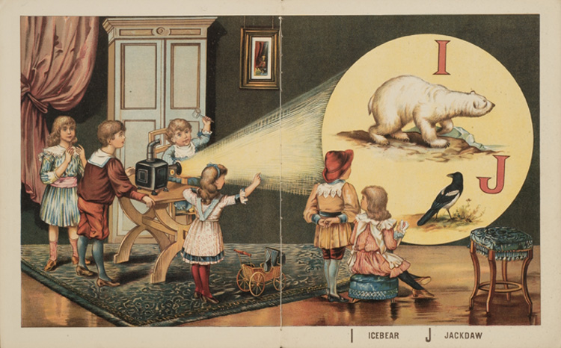
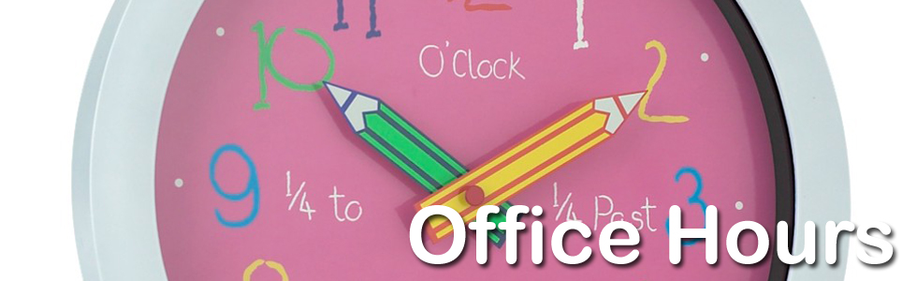

April 2017

ISPPU Events
In This Issue
- Children’s Meet-ups
Mon, 10:00 AM (Weekly)
- ISPPU Office Hour
Weds, Apr 5 & 12
- Book Club
Tue, Apr 18
- Career Kickoff Workshop:
Design Your Life 2.0
Wed, Apr 19
- Lunch & Chat:
Let’s Talk About ISPPU
Fri, Apr 21
- A Very Merry Unbirthday
Sat, Apr 22
- Guided Tour of PU Art Museum
Sat, Apr 29
- Communiversity
Sun, Apr 30

Children’s Meetup

Mondays | 10:00 AM – 12:00 PM | Cotsen Children’s Library (Inside Firestone Library)
It takes a village to raise a child, so why do it alone? Come to our weekly Children’s Meetup where little ones can play with each other while parents can share their childcare stories and tips. Contact Mel at konkel.mel@gmail.com for more information.

ISPPU Office Hour

Wed, Apr 5 & Apr 12 | 3:00 – 4:00 PM | LAS Int’l Bldg. Atrium Café
This is a pilot project testing the feasibility of and the demand for regular recurring office hours by the ISPPU Committee. Feel free to come with any question(s) about ISPPU or life in Princeton as an international. Open to all ISPPU members, their significant others, and their children. RSVP not required. Please drop by. In case the café is booked for other events, visit B50 of LAS Int’l Bldg.

Book Club

Tue, Apr 18 | 4:30 PM | Halo Pub, 9 Hulfish St
We’ll discuss Designing Your Life: How to Build A Well-lived, Joyful Life by Bill Burnett and Dave Evans. This #1 New York Times Best Seller on how to approach life through an iterative designing process: follow your heart, stay curious, reframe your mindset, and build your way forward. Firestone and the Princeton Public library have several copies. This book is also the basis of ISPPU Career Kickoff Workshops in March and April. Contact isppu@princeton.edu if you are interested in the book club or the workshops.

Contact us

Email: isppu@princeton.edu | Join Us: tinyurl.com/isppu-request | Facebook: www.facebook.com/groups/isppu

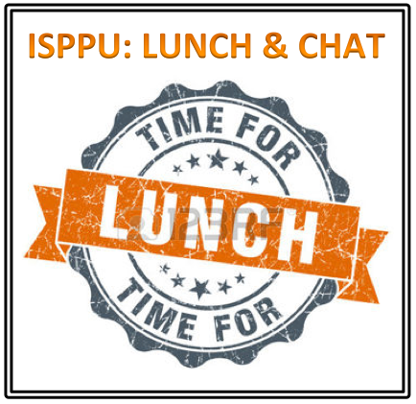

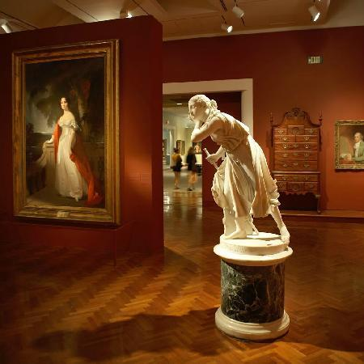

Career Kickoff Workshop: Design Your Life 2.0

Wed, Apr 19 | 7:00 – 8:30 PM | Louis A. Simpson (LAS) International Bldg. MPR B60B, 20 Washington Road

This is a continuation of our previous Career Kickoff Workshop. The workshop is based on a similar workshop offered by Princeton University Career Services and Keller Center for Innovation in Engineering Education. Suggested reading: Designing Your Life: How to Build A Well-lived, Joyful Life. Contact us at isppu@princeton.edu to RSVP by Mon, Apr 17.

Lunch & Chat: Let’s Talk About ISPPU

Fri, Apr 21 | 12:30 – 1:30 PM | Suite 301, 20 Washington Road
ISPPU is an organization for the spouses, but also by the spouses. Your input determines what ISPPU will be like for the next year. In this month’s Lunch & Chat, we will talk about ISPPU the organization, its structure, history, resources, limitations, membership, and leadership. Administrators from the Davis IC will also participate in this discussion. The discussion will be facilitated by Shefalika Gandhi, LCSW from UHS. Contact us at isppu@princeton.edu to RSVP by Wed, Apr 19.

A Very Merry Unbirthday

Sat, Apr 22 | 10:00 AM – 2:00 PM | Lakeside Commons and Grill Area
"An unbirthday is an event that is typically celebrated on any or all of the 364 (365 on leap years) days in which it is not the person's birthday." This will be a party to celebrate the birthdays (or unbirthdays) of all ISPPU children in one party. There will be party hats, crafts and games. ISPPU will provide hotdogs and cupcakes. Please bring a dish to share as the party will be during lunch time. Children of all ages are welcome (including adults). You do not need to have children to attend this event. All are welcome to help celebrate our ISPPU children! Please contact konkel.mel@gmail.com to RSVP by Wed, Apr 19.

Tour of Princeton U. Art Museum

Sat, Apr 29 | 3:00 – 4:00 PM | Princeton University Art Museum
We will visit a local treasure – the PUAM – a sister museum of the Metropolitan Museum. The tour will be guided by two PU Art Museum docents, who will highlight the most valuable collections, as well as some Roman, African, and Asian art. The tour is free of charge for ISPPU members and their family members. You may bring your children to the event but strollers should be left in the lobby. Please contact isppu@princeton.edu to let us know who will be coming. Spots are limited, RSVP by Wed, Apr 26.

Communiversity

Sun, Apr 30 | 1:00 – 6:00 PM | Courtyard In Front of Nassau Hall
Every year the Municipality of Princeton and the University celebrates the synergy between the community and the university with a big fanfare called the Communiversity. There will be information booths for many local shops and university organization. ISPPU will have a booth at the Communiveristy. We need ISPPU ambassadors to be at the booth and simply chat to anyone who stops by about ISPPU. Please contact isppu@princeton.edu if you are willing to help out.

uPCOMING EVENTS hIGHLIGHT (TBD)
Campus / Community
- Davis International Center
www.princeton.edu/davisic
- PU Public Events Calendar
www.princeton.edu/events
- Tigers with Cubs (for Childcare)
www.princeton.edu/~tigerswc
- Princeton Public Library
www.princetonlibrary.org

uPCOMING EVENTS
- Lunch & Chat
Fri, May 19
- Career Kickoff Workshop
Wed, May 3

TBD Events
- Trip to Asian Food Market
- Go Tigers Scavenger Hunt
- Stargazing in Peyton Hall Observatory

ISPPU is planning to organize the events below but we have not set a date. We are looking for volunteers to help out organizing these events. Please contact us to indicate interest – as a participant or organizer – and let us know your comments or suggestions for these events. We’ll try to incorporate your feedback in the actual events.

Trip to Asian Food Market / H-Mart
We will visit Asian Food Market in Plainsboro or H-Mart, the Korean specialty food store in Edison. Spaces are limited. Drivers needed. Please contact isppu@princeton.edu to indicate interest.

Go Tigers Scavenger Hunt
This is a family friendly event where we hunt for the wonders of Princeton University Campus – like dinosaur fossils or rare species of trees. Please contact isppu@princeton.edu to indicate interest.

Stargazing in Peyton Hall Observatory
There is an observatory in the astronomy department in Peyton Hall. We are exploring the possibility of a tour for stargazing through the telescope there for ISPPU members. Please contact isppu@princeton.edu to indicate interest.

