isppu news
International Spouses and Partners of Princeton University



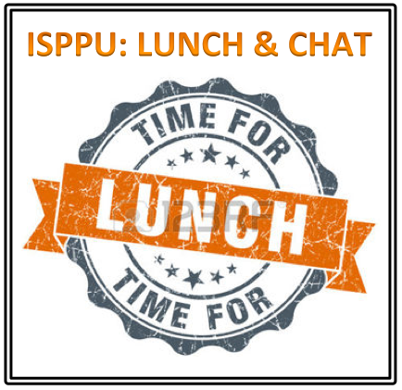

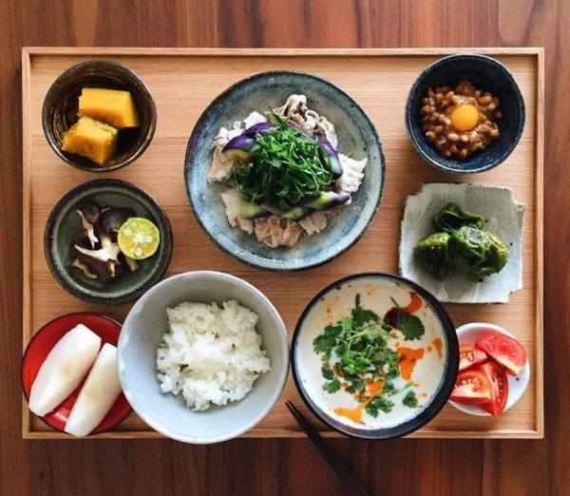
March 2017

ISPPU Events
In This Issue
- Career Kickoff Workshop:
Design Your Life 1.0
Wed, Mar 8
- Little Tea House
Fri, Mar 10
- ISPPU’s 6th Birthday
Sat, Mar 18
- Lunch & Chat:
Home Away from Home
Fri, Mar 24
- Japanese Cooking Class
Sun, Mar 26
- Book Club (Postponed)
Tue, Apr 18
- Children’s Meet-ups
Mon, 10:00 AM (Weekly)

Career Kickoff Workshop: Design Your Life 1.0

Wed, Mar 08 | 7:00 – 8:30 PM | Louis A. Simpson International Bldg. MPR B60B, 20 Washington Road

Do you believe your degree determines your career? Reframe it. Three-quarters of all college grads don’t work in a career related to their major. We will discuss ways to reframe dysfunctional beliefs that might be holding back your career or life. The workshop is based on activities proposed by Stanford professors Bill Burnett and Dave Evans in their #1 New York Times Best Seller Designing Your Life: How to Build A Well-lived, Joyful Life. Contact us at isppu@princeton.edu to RSVP by Mon, Mar 6.

* The same workshop is offered by Princeton University Career Services and Keller Center for Innovation in Engineering Education to graduate students only.

Little Tea House

Fri, Mar 10 | 3:00 – 6:00 PM | Lawrence Apartments
Our cozy Little Tea House is a monthly event where premium quality Chinese tea will be served as part of a Chinese Tea Ceremony. We'll also talk about anything that comes to our mind while we are enjoying the tea, be it fun things to do, or any challenge you're going through. Contact us at isppu@princeton.edu for more information.

ISPPU’s 6th Birthday

Sat, Mar 18 | 5:00 – 9:00 PM | Friend Center Convocation Room
Let’s celebrate the 6th Birthday of our very own organization. Six years ago, a group of spouses and partners of Princeton University's international graduate students and scholars created this group. A delicious cake will be generously sponsored by the Davis International Center. Let's each bring our favorite food to share with other ISPPU members. You are welcome to come with your family members. Transportation Tips: You can take the TigerTransit Saturday Weekender which runs till 9 PM on Saturdays and get off at Friend Center. Please contact isppu@princeton.edu to RSVP by Wed, Mar 15.

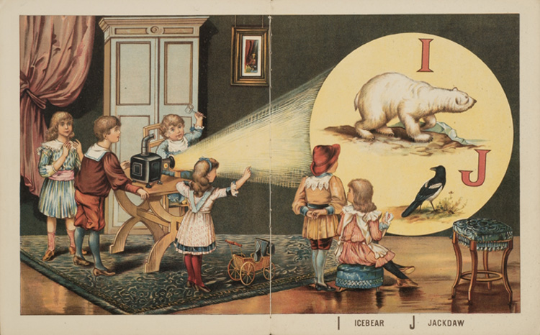

Lunch & Chat: Home Away from Home

Fri, Mar 24 | 12:30 – 1:30 PM | Suite 301, 20 Washington Road
Join us for an informal discussion on topics related to adjustment and transition to Princeton. Learn ways to navigate being an international spouse – since it can be a role of unique challenges, opportunities and responsibilities. Facilitated by Shefalika Ghandi, LCSW. Co-sponsored by Davis International Center and University Health Services. A light lunch will be provided. First come first served. Contact us at isppu@princeton.edu to RSVP by Wed, Mar 22.

Japanese Cooking Class

Sun, Mar 26 | 10:00 AM – 2:00 PM | Lawrence Apartments Community Kitchen
A long time ISPPU activity leader, Akiko Samsing, will teach us how to make staple Japanese food using ingredients from nearby grocery markets, so we can take home the recipe and reproduce them easily in our own kitchens. We can only accommodate 11 students and applicants are accepted on are first come first served basis. So act fast, email Akiko at haku12310925@gmail.com to RSVP NOW!
Campus Resources
- Davis International Center
www.princeton.edu/davisic
- PU Public Events Calendar
www.princeton.edu/events
- Tigers with Cubs (for Childcare)
www.princeton.edu/~tigerswc
Community Resources
- Princeton Public Library
www.princetonlibrary.org

uPCOMING EVENTS
- Lunch & Chat
Fri, Apr 21
- Lunch & Chat
Fri, May 19
- Career Kickoff Workshop
Wed, Apr 19
- Career Kickoff Workshop
Wed, May 3

*You are welcome to bring your children. | Guest parking available. | Class located within walking distance from TigerTransit Lawrence Apartments stop. | The menu is yet to be finalized. | Ingredients may contain allergens. | If you signed up but later on decided not to attend, please cancel your RSVP by 03/23/2017 to be considerate of wait-listed attendees.

Book Club (Postponed to April)

Tue, Apr 18 | 4:30 PM | Halo Pub, 9 Hulfish St
Join us for the discussion of Designing Your Life: How to Build A Well-lived, Joyful Life by Bill Burnett and Dave Evans. This #1 New York Times Best Seller on how to approach life through an iterative designing process: follow your heart, stay curious, reframe your mindset, and build your way forward. Firestone and the Princeton Public library have several copies. This book is also the basis of ISPPU Career Kickoff Workshops in March and April. Contact isppu@princeton.edu if you are interested in the book club or the workshops.

Children’s Meetup

Mondays | 10:00 AM – 12:00 PM | Cotsen Children’s Library (Inside Firestone Library)
It takes a village to raise a child, so why do it alone? Come to our weekly Children’s Meetup where little ones can play with each other while parents can share their childcare stories and tips. Contact Mel at konkel.mel@gmail.com for more information.

Contact us

Email: isppu@princeton.edu | Join Us: tinyurl.com/isppu-request | Facebook: www.facebook.com/groups/isppu

