isppu news
International Spouses and Partners of Princeton University





February 2017

ISPPU Events
In This Issue
- Winter Drinks Round 2!
Sunday, Feb 5
- Career Kickoff Workshop:
By University Career Services
Wednesday, Feb 8
- ISPPU Open House
Friday, Feb 10
- Little Tea House
Thursday, Feb 17
- Lunar New Year Party
Saturday, Feb 18
- Book Club
Tuesday, Feb 21
- Lunch & Chat:
Home Away from Home
Friday, Feb 24
- Children’s Meet-ups (Weekly)
Mondays, 10:00 AM

Winter Drinks Round 2!

Sunday, Feb 5 | 7:00 – 10:00 p.m. | Triumph Brewing, 138 Nassau St
Come join us for some good conversation and a beverage of choice! Some may need a warm Irish coffee or hot chocolate to help warmup from the cold, while others are wondering where winter is (namely the Canadians) and will need something to cool them down like a cold beer, iced cocktail, or coca-cola. Whatever you fancy we'd love to see you! Feel free to invite friends but please RSVP the number of people you will be bringing so we can make a reservation. Please register at https://www.facebook.com/events/733721356794657.

Career Kickoff Workshop: By University Career Services

Wednesday, Feb 08 | 7:00 – 8:30 PM | Louis A. Simpson International Bldg. MPR B60B, 20 Washington Road

Seeking career opportunities? Trying to adjust to the U.S. job seeking culture? Confused about work authorization? Join us for a workshop offered by the Princeton University Career Services solely for International Spouses and Partners! Please register at https://goo.gl/aUTqbd.

ISPPU Open House

Friday, Feb 10 | 12:00 – 2:00 p.m. | MPR B60AB, 20 Washington Road
New to Princeton? Come to our Open House! Find out what ISPPU has to offer. Meet amazing people who are in situations similar to yours. A light lunch will be provided for all registered attendees and a few walk-in attendees. Transportation Tips: Take any TigerTransit shuttle that stops at Woodrow Wilson School. Please contact isppu@princeton.edu to RSVP.

Lunar New Year Party

Saturday, Feb 18 | 5:00 – 9:00 PM | Friend Center Convocation Room
Throughout Asia people celebrate the Lunar New Year. It is a time for reunions with family, visits to relatives and friends, fancy feasts, and extended vacation. Join us for a celebration! We will also have dumplings, a staple food for many Chinese during the Lunar New Year. Please bring a side dish to keep us well fed, a joyous heart to reconnect with old friends and make some new friends, and lots of laughter to make our day! You are welcome to come with your family members.
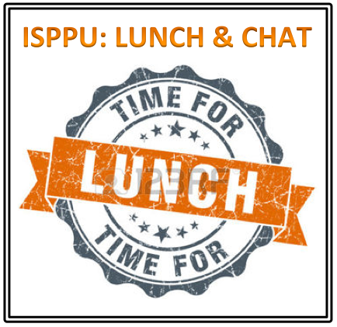
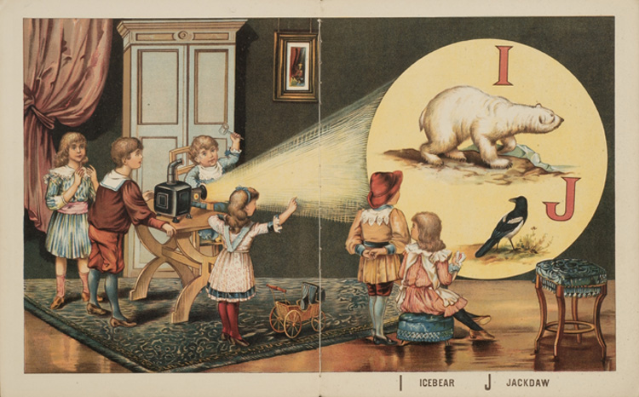


Please register at https://LunarNewYear2017ISPPU.eventbrite.com.

Little Tea House

Friday, Feb 17 | 3:00 – 5:00 PM | Lawrence Apartments
Our cozy Little Tea House is a monthly event where premium quality Chinese tea will be served as part of a Chinese Tea Ceremony. We'll also talk about anything that comes to our mind while we are enjoying the tea, be it fun things to do, or any challenge you're going through. Contact us at isppu@princeton.edu for more information.
Campus Resources
- Davis International Center
intlnews@princeton.edu
- PU Public Events Calendar
www.princeton.edu/events
- Tigers with Cubs (for Childcare)
www.princeton.edu/~tigerswc
Community Resources
- Princeton Public Library
www.princetonlibrary.org

uPCOMING EVENTS
- Career Kickoff Workshop
Wednesday, March 8
- ISPPU Birthday Party
Saturday, March 18
- Career Kickoff Workshop
Wednesday, April 19
- Career Kickoff Workshop
Wednesday, May 3

Book Club

Tuesday, Feb 21 | 4:30 PM | Halo Pub, 9 Hulfish St
Join us for the discussion of this shocking and beautiful novel on how a dysfunctional, seemingly traditional Seoul family implodes because Yeong-hye, the youngest of three, decides to stop eating meat, after a disturbing dream. And how they treat her decision as a disease, as vegetarianism remains uncommon in Korea. Firestone and the Princeton Public library have several copies. Contact isppu@princeton.edu if you are interested.

Lunch & Chat: Home Away from Home

Friday, Feb 24 | 12:30 – 1:30 PM | Suite 301, 20 Washington Road
Join us for an informal discussion on topics related to adjustment and transition to Princeton. Learn ways to navigate being an international spouse – since it can be a role of unique challenges, opportunities and responsibilities. Facilitated by Shefalika Ghandi, LCSW. Co-sponsored by Davis International Center and University Health Services. A light lunch will be provided. First come first served. Contact us at isppu@princeton.edu for more information.

Children’s Meetup

Mondays | 10:00 AM – 12:00 PM | Cotsen Children’s Library (Inside Firestone Library)
It takes a village to raise a child, so why do it alone? Come to our weekly Children’s Meetup where little ones can play with each other while parents can share their childcare stories and tips. Contact Mel at konkel.mel@gmail.com for more information.

Contact us

Email: isppu@princeton.edu | Join Us: tinyurl.com/isppu-request | Facebook: www.facebook.com/groups/isppu

