isppu news
International Spouses and Partners of Princeton University

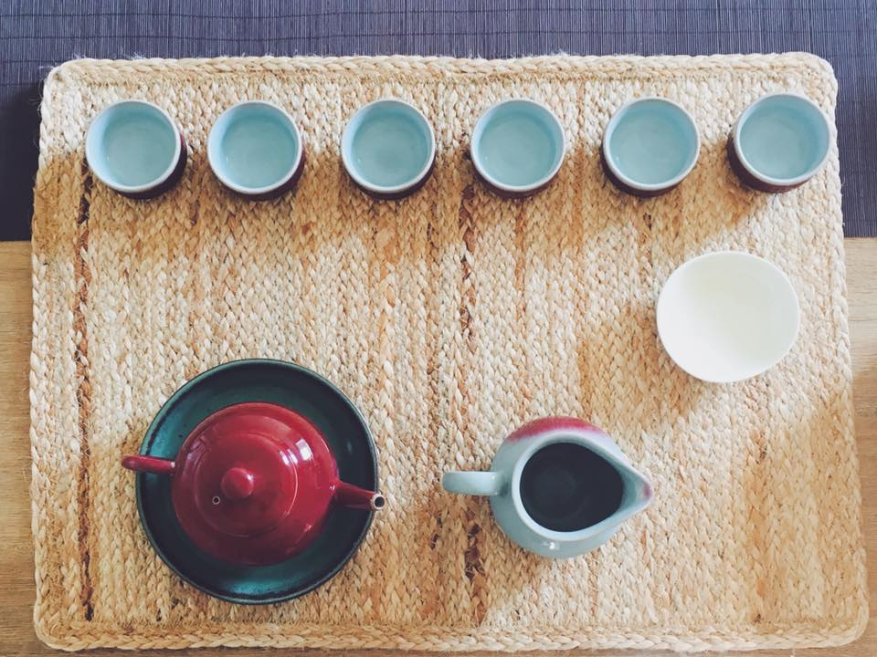

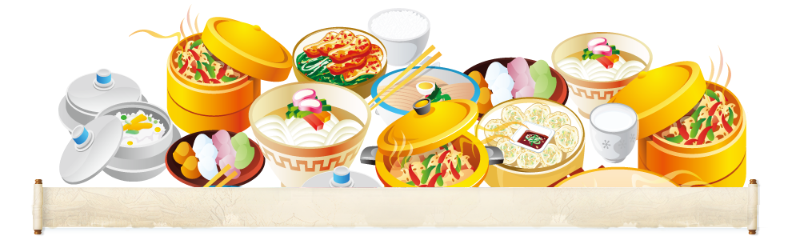
January 2017

ISPPU Events
In This Issue
- Little Tea House
Friday, January 13
- Chinese Cooking Class
Saturday, January 14
- Book Club
Tuesday, January 17
- Lunch & Chat:
Home Away from Home
Friday, January 20
- Career Kick-off Workshop:
Skill-based Volunteering
Wednesday, January 25
- Children’s Meet-ups (Weekly)
Mondays, 10:00 a.m.

Little Tea House

Friday, January 13 | 3:00 – 5:00 p.m. | Lawrence Apartments
Our cozy Little Tea House is a monthly event where premium quality Chinese tea will be served as part of a Chinese Tea Ceremony. We'll also talk about anything that comes to our mind while we are enjoying the tea, be it fun things to do, or any challenge you're going through.
Contact us if you have any questions (isppu@princeton.edu).

Chinese Cooking Class

Saturday, January 14 | 10:00 a.m. – 2:00 p.m. | Lawrence Apartments

Wanna have some authentic Chinese food? Cantonese Style Porridge, BBQ Tofu, Cucumber Salad, Fish & Mushroom Soup? Join us for a Chinese Cooking Class! Space is limited. You will need a free Eventbrite account to register and get your free ticket. Open to spouses / partners. Each adult may bring up to two children to this event.

Please register at https://chinesecookingclassjan142017.eventbrite.com.

Book Club

Tuesday, January 17 | 4:30 p.m. | Halo Pub, 9 Hulfish St
Join us for the discussion of Normal by Warren Ellis. In this fascinating and provocative near-future techno-thriller, the hero of this book monitors an intricate worldwide surveillance system as part of an effort to save the world from a looming cataclysm that could bring financial ruin. Find out how he becomes a scapegoat charged for murder and how he clears these charges. The Princeton Public library has several copies of this book.
Contact us if you have any questions (isppu@princeton.edu).

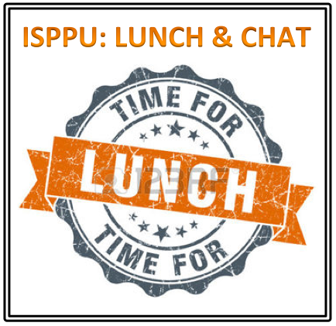
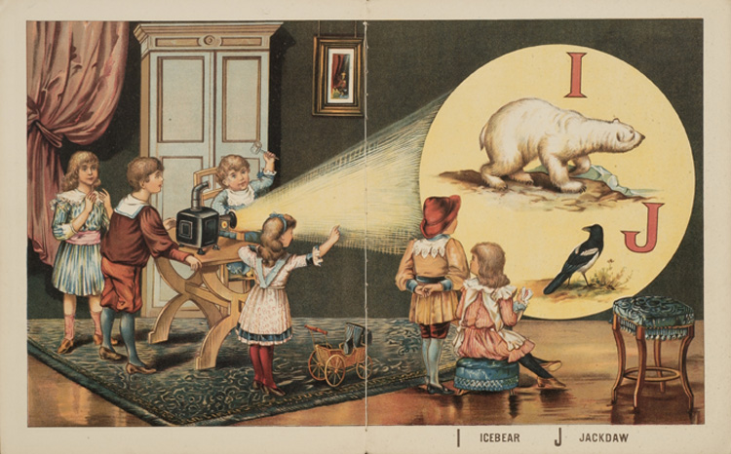
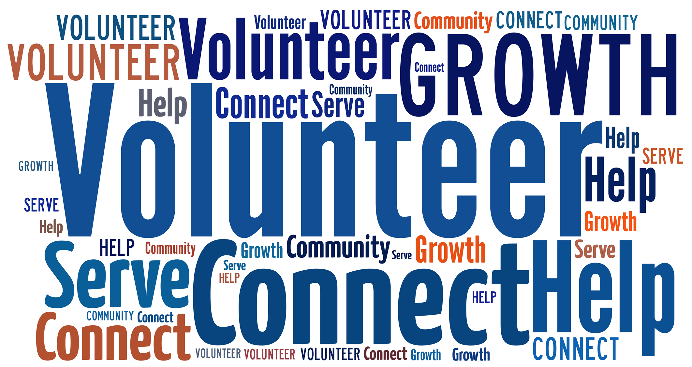
ISPPU Events (Continued)

Lunch & Chat: Home Away from Home

Friday, January 20 | 12:30 – 1:30 p.m. | 20 Washington Road (Davis International Center)
Campus Resources
- Davis International Center
intlnews@princeton.edu
- PU Public Events Calendar
www.princeton.edu/events
- Tigers with Cubs (for Childcare)
www.princeton.edu/~tigerswc
Community Resources
- Princeton Public Library
www.princetonlibrary.org

uPCOMING EVENTS
- Career Kick-off Workshop: Presentation by Princeton University Career Services
Wednesday, February 8
https://goo.gl/aUTqbd
- ISPPU Open House
Friday, February 10
- Lunar New Year Party
Saturday, February 18
- ISPPU Birthday Party
Saturday, March 18

Join us for an informal discussion on topics related to adjustment and transition to Princeton. Learn ways to navigate being an international spouse – since it can be a role of unique challenges, opportunities and responsibilities. Facilitated by Shefalika Ghandi, LCSW. Co-sponsored by Davis International Center and University Health Services. A light lunch will be provided. First come first served.
Contact us if you have any questions (isppu@princeton.edu).

Career Kick-off Workshop: Skill-based Volunteering

Wednesday, January 25 | 2:30 – 3:30 p.m. | Location: TBD
ISPPU is proud to bring you a brand new program – Career Kick-off Workshop Series. The first workshop is a talk about pro bono work (skill-based volunteering) tailored to international spouses and partners. You will learn how to hone your skills and apply your professional expertise to make a real difference. The speaker is Amy Klein, the executive director of VolunteerConnect, an organization based in Princeton township matching volunteers to projects.
Please RSVP. Event registration link is https://goo.gl/yodq8x.

Children’s Meetup

Mondays | 10:00 a.m – 12:00 p.m. | Cotsen Children’s Library (Inside Firestone Library)
It takes a village to raise a child, so why do it alone? Come to our weekly Children’s Meetup where little ones can play with each other while parents can share their childcare stories and tips. First meetup of the year 2017 will be on Jan 9th.
Contact Mel Konkel if you have any questions (konkel.mel@gmail.com).

Contact us
Email: isppu@princeton.edu
Facebook: www.facebook.com/groups/isppu
Membership Request: tinyurl.com/isppu-request

