isppu news
International Spouses and Partners of Princeton University



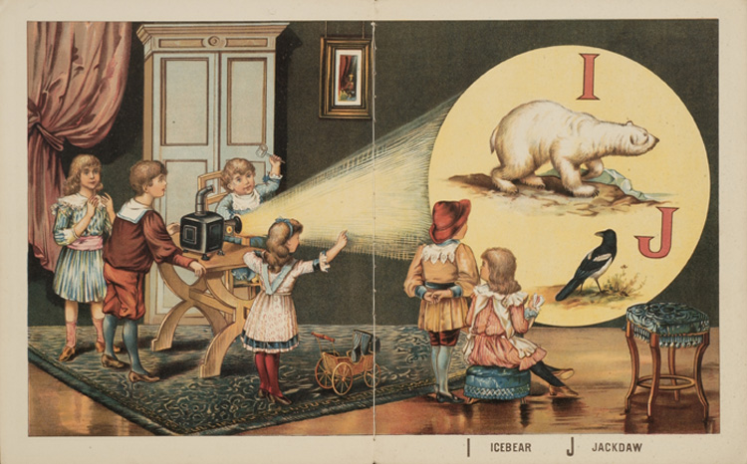
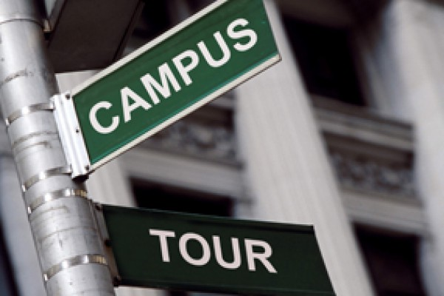
Oct 1 – Oct 15, 2016

ISPPU Events
In This Issue
- Princeton Campus Tour
Saturday, October 1
- ISPPU Book Club
Tuesday, October 4
- ISPPU Afternoon Tea
Fridays, 3:30 p.m.
- Children’s Meet-ups
Mondays, 10:00 a.m.
Campus Resources
- Davis International Center
intlnews@princeton.edu
- PU Public Events Calendar
www.princeton.edu/events
- Tigers with Cubs (for Childcare)
www.princeton.edu/~tigerswc
Community Resources
- Princeton Public Library
www.princetonlibrary.org

Princeton Campus Tour

Saturday, October 1 | 1:00 – 3:00 p.m. | FitzRandolph Gate
Recently relocated to Princeton? Come and take a guided tour of the beautiful campus! Family friendly. Rain date: Sunday, October 2, same time and location.

ISPPU Book Club

Tuesday, October 4 | 5:00 p.m. | Halo Pub, 9 Hulfish St, Princeton, NJ
This month we will discuss poetry books by Emily Dickinson! You don’t have to read an entire book, as you can find many of her poems online.

ISPPU Afternoon Tea

Fridays | 3:30 p.m. | Genomics Café, Lobby of Carl Icahn Laboratory
Join us for our weekly ISPPU Afternoon Tea on Fridays to introduce yourself, connect with fellow ISPPU members, learn about upcoming ISPPU events, or just for a casual chat. Please bring your own coffee, tea, water, or snacks.

Children’s Meetup

Mondays | 10:00 a.m. | Cotsen Children’s Library (Inside Firestone Library)
It takes a village to raise a child, so why do it alone? Come to our weekly Children’s Meetup where little ones can play with each other while parents can share their stories and tips. Meetups are scheduled to start in late September or early October. Check our Facebook group for details and updates.

Contact us
Email: isppu@princeton.edu
Facebook: www.facebook.com/groups/isppu
Membership Request: tinyurl.com/isppu-request

