isppu news
International Spouses and Partners of Princeton University




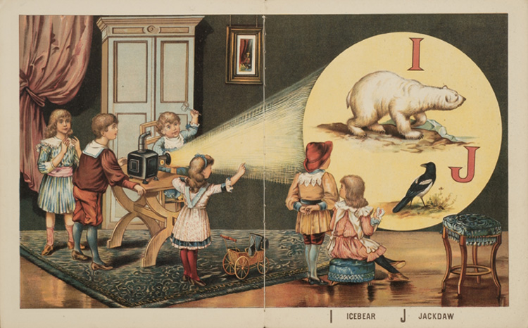
September 2016

ISPPU Events
In This Issue
- Reading Challenge
Thursday, September 1
- ISPPU Open House
Friday, September 23
- ISPPU Afternoon Tea
Fridays, 3:30 p.m.
- Children’s Meetup
Campus Resources
- Davis International Center
intlnews@princeton.edu
- PU Public Events Calendar
www.princeton.edu/events
- Tigers with Cubs (for Childcare)
www.princeton.edu/~tigerswc
Community Resources
- Princeton Public Library
www.princetonlibrary.org

ISPPU Book Club Reading Challenge 2016

Thursday, September 1 | 6:00 p.m. | infini-T Cafe, 4 Hulfish St, Princeton, NJ
Come to our very first meeting of ISPPU Book Club for this new academic year and share with fellow ISPPU members the books you read over the summer! If you want to participate in the Reading Challenge, visit our Facebook group (www.facebook.com/groups/isppu) for details.

ISPPU Open House

Friday, September 23 | 12:00 – 2:00 p.m. | 1985 Meeting Room, Carl Fields Center, 58 Prospect Ave, Princeton, NJ 08544
Recently relocated to Princeton? Come and join us! All spouses and partners of international scholars and graduates are invited to our welcome reception. Food and drinks will be served. Registration required. Visit our Facebook group for updates and registration.

ISPPU Afternoon Tea

Fridays | 3:30 p.m. | Genomics Café, Lobby of Carl Icahn Laboratory
Join us for our weekly ISPPU Afternoon Tea on Fridays to introduce yourself, connect with fellow ISPPU members, learn about upcoming ISPPU events, or just for a casual chat. Please bring your own coffee, tea, water, or snacks.

Children’s Meetup

Time and Location: TBD
It takes a village to raise a child, so why do it alone? Come to our weekly Children’s Meetup where little ones can play with each other while parents can share their stories and tips. Meetups are scheduled to start in late September or early October. Check our Facebook group for details and updates.

