isppu news
International Spouses and Partners of Princeton University

July 2016
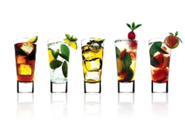
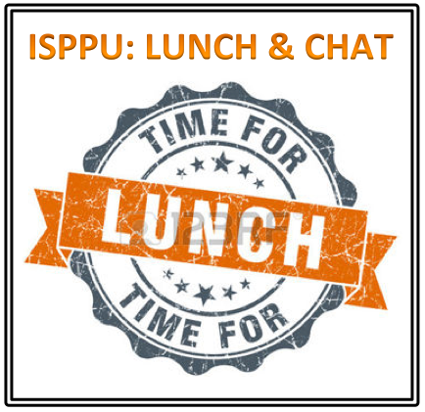
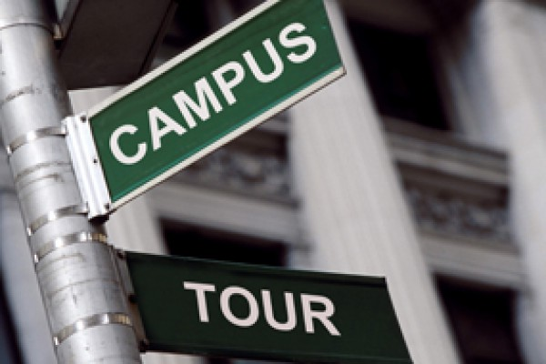


ISPPU Events
In This Issue
- Summer Drinks, 3.0
Wednesday, July 6
- Campus Tour
Saturday, July 9
- Lunch & Chat
Fridays, 12:30 p.m.
- French Class
Tuesdays, 10:00 a.m.
Campus Resources
- Davis International Center
- PU Public Events Calendar
- Tigers with Cubs (for Childcare)
Community Resources
- Princeton Public Library

Summer Drinks, 3.0

Wednesday, July 6 | 5:00 p.m. | Ivy Inn, 248 Nassau St, Princeton, NJ 08542
Summer is here! Let's chillax and celebrate with a few drinks, soda, or even a burger in town at Ivy Inn!

Campus Tour

Saturday, July 9 | 4:00 – 5:30 p.m. | FitzRandolph Gate
Ever curious what’s that gorgeous building around the corner for? Wanna know more about the history of the university? Join us for a guided campus tour!

Lunch & Chat

Fridays | 12:30 p.m. | Café Vivian, Frist Campus Center
Join us for our weekly ISPPU Lunch & Chat on Fridays in front of Café Vivian. You can bring your own food or just grab something to eat from Café Vivian or Food Gallery at Frist. Children are welcome.

French Classes

Tuesdays | 10:00 – 11:00 a.m. | Chancellor Green Café
We will start with some basics, and then practice and converse in French in a friendly setting with the instructor. The class will be adults only. Visit our Facebook group for updates.

lOOKING FOR MORE EVENTS / Resources?
Check out Princeton University Public Events Calendar (www.princeton.edu/events), Davis International Center newsletter (intlnews@princeton.edu), Princeton Public Library website (www.princetonlibrary.org), and Tigers with Cubs homepage (www.princeton.edu/~tigerswc ) for more details.

