isppu news
International Spouses and Partners of Princeton University


June 2016
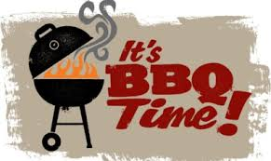
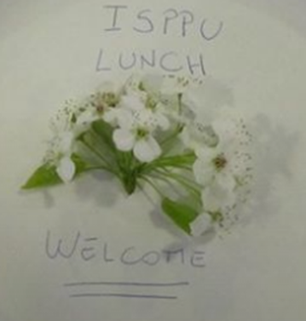
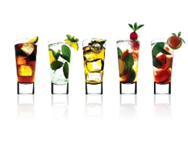

ISPPU Events
In This Issue
- Summer Drinks Happy Hour Thursday, June 2
- Summer BBQ
Saturday, June 4
- Lunch & Chat
Fridays, 12:30 p.m.
- French Class
Tuesdays, 10:00 a.m.
Campus Resources
- Davis International Center
- PU Public Events Calendar
- Tigers with Cubs (for Childcare)
Community Resources
- Princeton Public Library

Summer Drinks Happy Hour

Thursday June 2 | 6:00 p.m. | Yankee Doodle Tap Room, 10 Palmer Square, Princeton, New Jersey
Summer is on its way, and holidays are approaching, so let's chillax and celebrate with a few drinks, soda, or even a burger in town at the Yankee Doodle Tap! The Ivy Inn Pub has a karaoke session at 10 PM later that same evening.

Summer BBQ – Registration Required

Saturday, June 4 | 5:00 – 8:00 p.m. | Lakeside Apartments, Grill Area
We will provide the food and grill. Open to international graduate students, post-docs, spouses, and children. Visit our Facebook group (link in the footer) for latest updates & registration.

Lunch & Chat

Fridays | 12:30 p.m. | Café Vivian, Frist Campus Center
Join us for our weekly ISPPU Lunch & Chat on Fridays in front of Café Vivian. You can bring your own food or just grab something to eat from Café Vivian or Food Gallery at Frist. Children are welcome.

French Classes

Tuesdays | 10:00 – 11:00 a.m. | Princeton Public Library, Study Room
We will start with some basics, and then practice and converse in French in a friendly setting with the instructor. The class will be adults only. Visit our Facebook group for updated study room number one hour before class starts.

lOOKING FOR MORE EVENTS / Resources?
Check out Princeton University Public Events Calendar (www.princeton.edu/events), Davis International Center newsletter (intlnews@princeton.edu), Princeton Public Library website (www.princetonlibrary.org), and Tigers with Cubs (www.princeton.edu/~tigerswc ) homepage for more details.

